**Helpful Reference Materials**

Resources to understand the context of the problem

* Middle East Institution Iranian sanction evasion

<https://www.mei.edu/publications/iranian-sanctions-evasion-and-gulfs-complex-oil-trade>

* Satellites, Big Data help US spy on Smugglers of Iranian oil

<https://www.wsj.com/articles/as-new-iran-sanctions-loom-oil-smuggling-is-a-tougher-racket-1541076444>

Resources to understand the development of a computer vision model

* Deep Learning for Ship Detection and Segmentation: An end to end pipeline for deep learning on satellite imagery - Abhinav Sagar

<https://towardsdatascience.com/deep-learning-for-ship-detection-and-segmentation-71d223aca649>

* Airbus Ship Detection Challenge on Kaggle

<https://www.kaggle.com/c/airbus-ship-detection/overview>

Resources to test your model and ability to amalgamate satellite imagery work with AIS position data

* Satellite image to run your trained computer vision model on

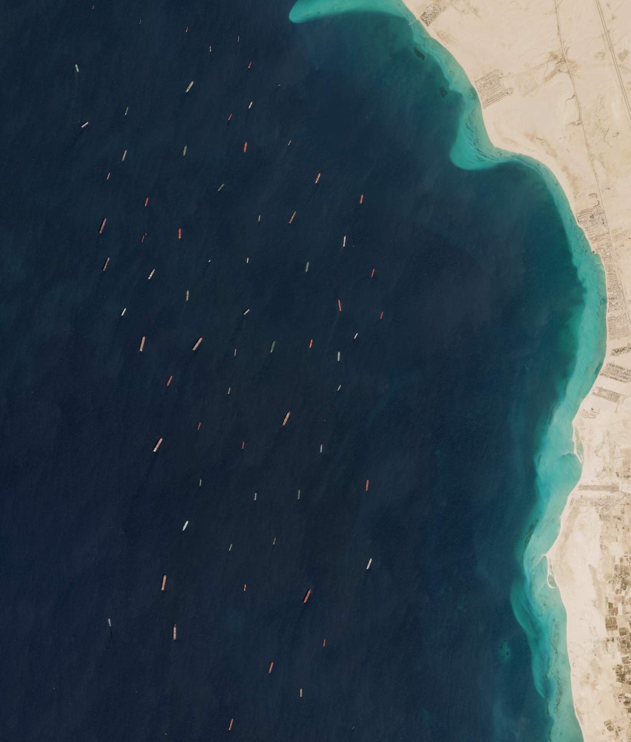

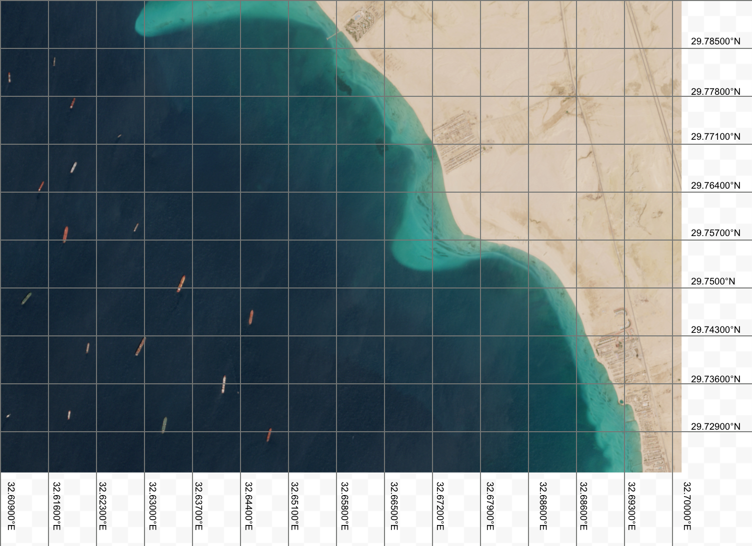

* For the purposes of this case study, these are the coordinates of the ships in the area shown in this satellite image pulled from vesseltracker.com. Vesseltracker.com records the position of ships via their AIS transponders. This position data was recorded at the same time that the satellite image was taken.

| **Latitude** | **Longitude** |
| --- | --- |
| 29.781°N | 32.611°E |
| 29.783°N | 32.617°E |
| 29.777°N | 32.619°E |
| 29.772°N | 32.626°E |
| 29.765°N | 32.615°E |
| 29.768°N | 32.620°E |
| 29.759°N | 32.628°E |
| 29.749°N | 32.612°E |
| 29.746°N | 32.646°E |
| 29.741°N | 32.622°E |
| 29.732°N | 32.611°E |
| 29.732°N | 32.619°E |
| 29.731°N | 32.633°E |
| 29.729°N | 32.648°E |